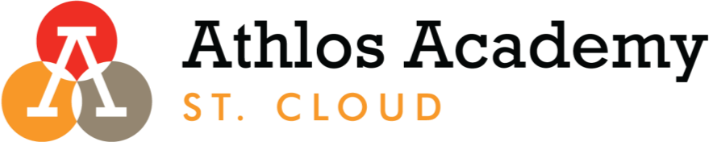

Athlos Academy of St. Cloud, MN - School Board Schedule
2022-2023

August 18th Finance Committee 8:00 AM
August 31st School Board 8:00 AM

September 22nd Finance Committee 8:00 AM
September 28th School Board 8:00 AM

October 20th Finance Committee 8:00 AM
October 26th School Board 5:00 PM

November 17th Finance Committee 8:00 AM
November 30th School Board 8:00 AM

December 15th Finance Committee 8:00 AM

January 19th Finance Committee 8:00 AM
January 25th School Board 8:00 AM
January 25th Development Committee 8:45 AM
January 25th Personnel Committee 9:15AM

February 23rd Finance Committee 8:00 AM

March 23rd Finance Committee 8:00 AM
March 29th School Board 8:00 AM
March 29th Development Committee 8:45AM

April 20th Finance Committee 8:00 AM
April 26th School Board 8:00 AM
April 26th Executive Committee 8:45AM

May 25th Finance Committee 8:00 AM
May 31st School Board 8:00 AM
May 31st Personnel Committee 8:45 AM

June 5th Finance Committee 8:00 AM
June 5th School Board 8:30 AM

